**FitFood,**

**An Online Food Delivery Application**

**User Interface Testing**

Contents

Test 1: Registration 3

• Process 1: Submitting the form with empty fields 3

• Process 2: Filling in invalid user details 4

• Process 3: Registering with the correct required details 5

Test 2: Logging In 7

• Process 1: Logging in with empty fields 7

• Process 2: Logging in with valid user details 8

Test 3: Home Page 9

• Process 1: Navigating through the ‘Restaurants’ 9

• Process 2: Restaurant Menu 9

• Process 3: Check-box for food items 9

• Process 5: View Cart 9

Test 5: Checkout 10

• Process 1: Pressing the ‘Checkout’ button 10

Test 9: Logging Out 10

• Process: Clicking the ‘Logout’ button 10

# Test 1: Registration

## Process 1: Submitting the form with empty fields

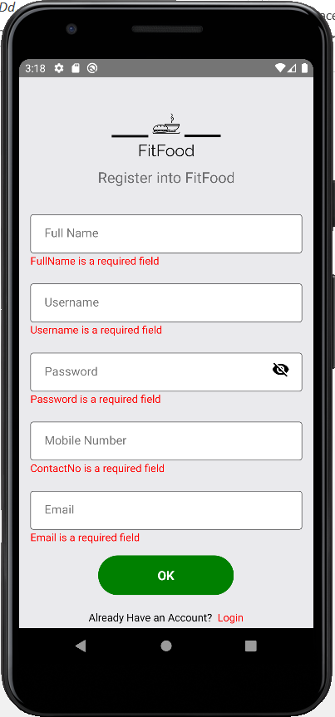

**Outcome:** An error message referring to empty fields is displayed where you have to enter each field for customer registration.

## Process 2: Filling in invalid user details

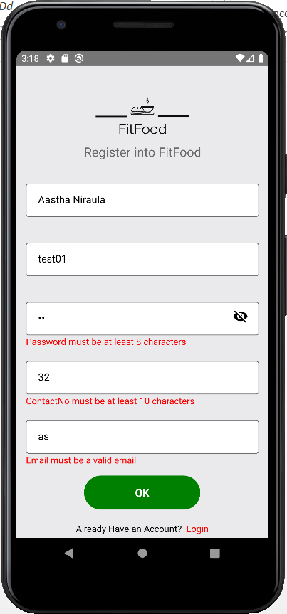

**Outcome:** An error message about the invalidity is displayed.

## Process 3: Registering with the correct required details

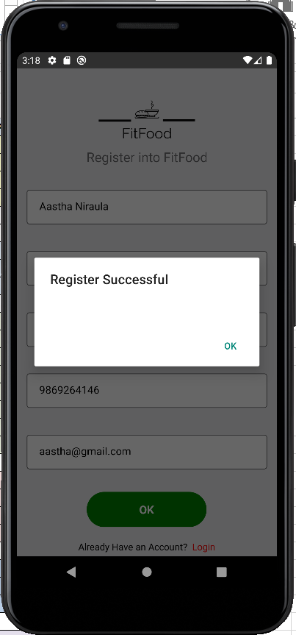

**Outcome:** A registration successful message is displayed if all the fields are entered correctly and all the criteria are met.

# Test 2: Logging In

## Process 1: Logging in with empty fields

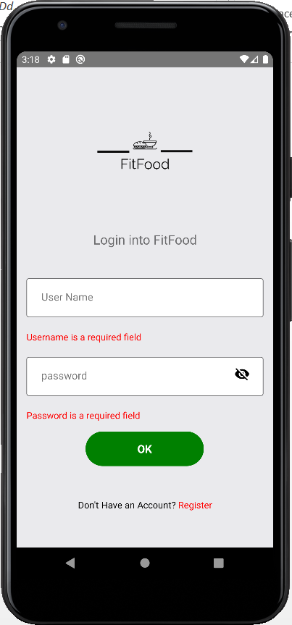

**Outcome:** An error message referring to empty login fields is displayed where the user is required to fill all the fields for login.

## Process 2: Logging in with valid user details

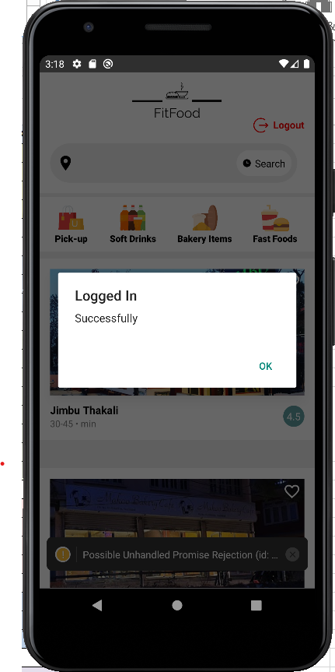

**Outcome:** Login is successful and the application is loaded.

# Test 3: Home Page

## Process 1: Navigating through the ‘Restaurants’

**Outcome:** A list of restaurants is displayed in the home page.

## Process 2: Restaurant Menu

**Outcome:** A page containing the digital menu of the food items of a particular restaurant is displayed.

# Test 4: Cart

## Process 3: Check-box for food items

**Outcome:** When the checkbox next to the food items is clicked, the food items is selected and then added to the cart.

## Process 4: View Cart

**Outcome:** When clicked on the ‘View Cart’ button, the user is navigated to the cart details. This contains information regarding total calories count and total amount of the list of food items selected.

# Test 5: Checkout

## Process 1: Pressing the ‘Checkout’ button

**Outcome:** A message box displaying that the order has been places is displayed in the screen with the description of the order.

# Test 6: Logging Out

## Process: Clicking the ‘Logout’ button

**Outcome:** The user is logged out and redirected to the application’s login page.